

Polycom VVX 250, 350, and 450 - Guide

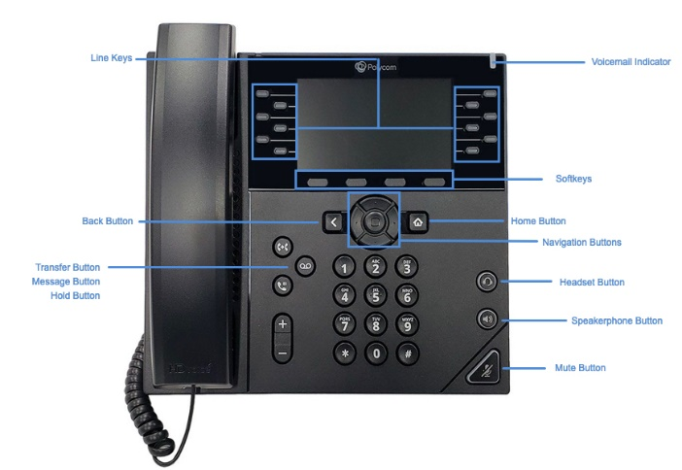

These Quick Tips apply to VVX 250, 350, and 450 business IP phones.

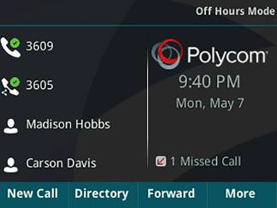 | Lines Screen  Displays phone lines, favorites, and conditional soft keys.  Available anytime.
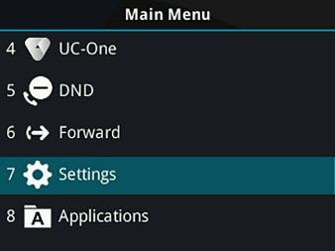 | Main Menu Screen  Displays menu options for settings and device information.  Available anytime.
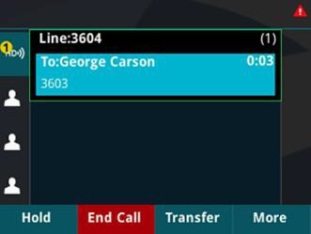 | Calls Screen  Displays all Active and Held calls.  Available when you have an Active or Held calls in progress.

Switch among Phone Screens
You can view any screen on your phone from other screens

To switch between screens:
» Press  to view the Lines, Main Menu, or Calls screen.
Place Calls
You can only have one active call in progress on your phone.

To place a call:
» Do one of the following:
- Pick up the handset, press or , enter the phone number, and press Send.
- Enter the phone number, press Dial, and pick up the handset, or press or .
- Select New Call, enter the phone number, and press Send.

Answer Calls
You can answer calls using the handset, speakerphone, or a headset.

To answer a call:
» Do one of the following:
- To answer with the speakerphone, press or press Answer soft key.
- To answer with the handset, pick up the handset.
- To answer with a headset, press .

View Recent Calls
You can view placed, received, and missed calls.

To view recent calls:
» Press the down navigation button .
End Calls
You can only end active calls. To end a held call, you must resume the call first.

To end an active call:
» Replace the handset in the cradle, press or , or press the End Call soft key.

To end a held call:
- Highlight the held call and press Resume.
- Press End Call.

Hold and Resume Calls
You can have multiple calls on hold and resume a call at any time.

To hold a call:
» Highlight the call and press the Hold soft key or press .

To resume a call
» Highlight the call and press the Resume soft key or press  .

Listen to Voicemail
When you have new voicemail messages, the red voicemail indicator will blink.

To listen to voicemail:
- Press .
- Follow the prompts.

Transfer Calls
You can transfer calls to any contact.

To transfer a call:
- Press and hold the Transfer soft key or press  .
- Choose Blind or Consultative. Consultative transfers allow you to speak to the person who will receive the call before transferring the call.
- Dial a number or choose a contact. You can see extensions in your building by pressing the Lines soft key.
If you chose Blind, the call is transferred immediately.

If you chose Consultative, press the Transfer soft key or press  after speaking with your contact.

Forward Calls
You can forward an incoming call to a contact or forward all incoming calls to a contact.

To forward an incoming call:
- On the Incoming Call screen, select Forward.
- Enter your contact’s number and select

Forward.

To forward all incoming calls:
- On the Main Menu screen, select Forward.
- If you have more than one line, select a line.
- Choose either Always, No Answer, or Busy.
- Enter a contact’s number, and select Enable.
If you chose No Answer, you can enter the number of rings before the call is forwarded.

To disable call forwarding:
- On the Main Menu screen, select Forward.
- If you have more than one line, select a line.
- Choose your forwarding type and select
Disable.
View the Contact Directory
You can view and add contacts to the Contact Directory.
To view the Contact Directory:
» Select Directories > Contact Directory.

To add a contact to the Contact Directory:
- In the Contact Directory, select Add.
- Enter the contact’s information and select

Save.
You can enter a number between 1 and 99 in the
Favorite Index field to make a contact a favorite.

Enable Do Not Disturb
You can enable Do Not Disturb when you do not want to receive calls.

To enable or disable Do Not Disturb:
» On the Main Menu screen, select DND.

Set Ringtones
You can set ringtones for incoming calls from all contacts and from individual contacts.

To set a ringtone for incoming calls:
» Select Settings > Basic > Preferences > Ring Type and select a ringtone.

